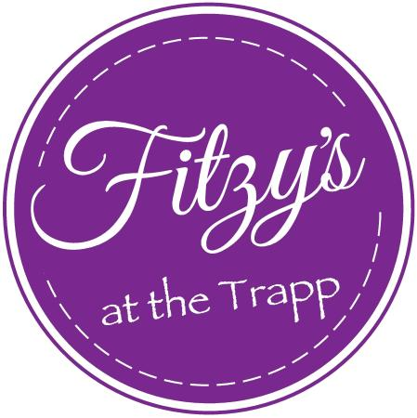

Small Plates
Hot Honey Fire Cracker Chicken Thighs £8.00
Gem Salad with Ceasar dressing, bacon, croutons, anchovy & parmesan mayo £7.00
Goats Cheese and Roasted Red Grape Bruschetta, Toasted Pine Nuts £9.00
Chefs Soup of the day served with crusty warm bread and butter (Ever-changing… just ask!) £7.00
Baked Camembert with honey, garlic and chilli flakes, chutney and baked bread £9.00
(GF bread)

Large Plates
8oz Sirloin Beef, cooked to your liking, served with baked mushroom, triple cooked chips, roasted tomato and rocket salad £25.00
Pan seared Salmon Fillet, crushed new potatoes with butter and chives, greens, Hollandaise sauce £19.00
Butterflied Chicken breast roasted in garlic butter, Aspen Fries, Rocket Salad £16.00
Pork Strips and sauteed mushrooms, cooked in a creamy peppercorn sauce served with fries and market vegetables £16.00
Forest Mushroom Risotto with spinach leaves and truffle flavours £16.00
Baked seabass with tenderstem broccoli and cherry tomatoes, sauteed potatoes, lemon and dill cream £19.50

Burgers
(served with side salad and French fries)

Chicken Ceasar Burger
Buttermilk Fried Chicken, Anchovy Mayo, Bacon, Gem Lettuce, Parmesan £17.00
Classic Beef Burger
8oz Beef Patty, Roasted Onions, Dill Pickle and burger sauce £17.00
(GF burger bun)
Fitzys Classics
6 Hour Braised Blade of beef, creamed potatoes, root vegetables and red wine gravy £18.00
Beer Battered Haddock, triple cooked chips, mushy peas, tartar and lemon £17.00
(GF batter)
Cheese and Onion Pie, Chunky Chips and Mushy Peas £17.00
Sides
Aspen fries £5.00
French fries £4.00
Hand cut chips £4.00
Onion rings (GF batter) £4.00
House salad £4.00
Market Vegetables £5.00

Sauces
ALL SAUCES £4.00 CHOOSE FROM:
Brandy and cracked black pepper
Bernaise
Traditional gravy

Dessert Menu

Selection of Dairy and non-Dairy Ice-creams - £7.00

Strawberry Cheesecake £7.70 fresh berries, dried raspberries

Sticky Toffee Pudding £8.00 served with butterscotch sauce and salted caramel ice-cream

Eton Mess £7.50 meringue, mixed berry coulis and Chantilly cream

Warm Chocolate Fudge Cake £8.00 vanilla ice-cream

Trio of Fresh Fruit Sorbets £7.00 Just ask for today’s flavours

